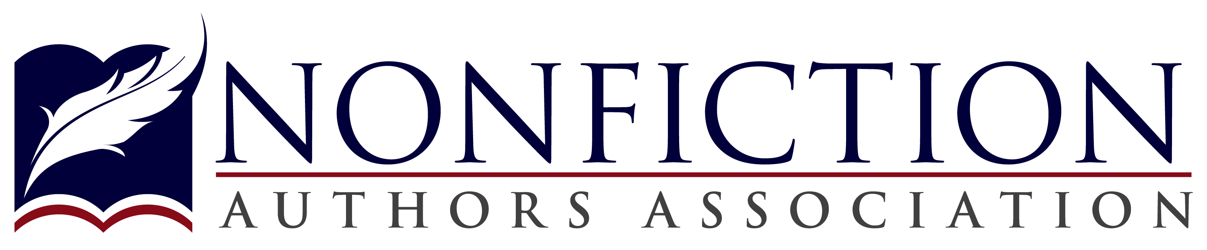
Aspiring or Experienced Nonfiction Writer?
• Join us for our fun and educational monthly meetings •

Dennis Vinar, Author and NFAA Chapter leader, introduces

“Editing Tips to Make You a Better Writer” by speaker Connie Anderson

Connie Anderson has been editing both non-fiction and general fiction books for over 25 years. She believes that the right editor can help make your book the best possible. Editing from the reader’s point of view ensures that the book’s message is clear, concise and accurate to any reader. She has also written In My Next Life I Want to be My Dog; When Polio Came Home: How Ordinary People Overcame Extraordinary Challenges; and The “I” of a Woman: How to Succeed in Life with Humor and Grace, all available on Amazon.
Connie@WordsandDeedsInc.com www.WordsandDeedsInc.com 952-835-4731
DATE: February 26, 2019
TIME: 6:30 PM
MEETING FEE: No charge
LOCATION: Creekside Condos
7100 Metro Blvd., Edina, MN 55439
(Park in lot)
Find us on Eventbrite.com or visit NonfictionAuthorsAssociation.com
(Hint: Snap a picture of this flyer so you have all the details!)

